
LESSON NOTE | DETAILED EXPLANATORY NOTES
BIOENERGY
HYDROGEN PRODUCTION VIA PHOTOSYNTHESIS (CYANOBACTERIAL)
GRADE 12 - BIOLOGY
■ ■ ■

What is Biohydrogen?
Hydrogen (H₂) is a very clean fuel: when it burns it combines with oxygen to make only water, with no carbon dioxide. Biohydrogen is hydrogen made by living organisms. In this lesson, we look at how certain photosynthetic microbes -the cyanobacteria -can use sunlight and water to produce hydrogen gas, a process sometimes called biophotolysis ('splitting water with light').
Because the energy comes from the Sun and the raw material is water, cyanobacterial hydrogen is a renewable and potentially carbon-free fuel. This lesson explains what cyanobacteria are, how they make hydrogen, the enzymes and the oxygen problem involved, and the promise and limitations of the technology -including its potential in sunny Papua New Guinea.
Why Cyanobacterial Hydrogen Matters
- Hydrogen is a clean fuel -burning it produces only water.
- The process uses sunlight and water, which are abundant and renewable.
- It is carbon-free -no CO₂ is released when the hydrogen is used.
- It shows how biology and biotechnology can help solve energy problems.
Hydrogen Production via Photosynthesis
Key Learning Outcomes
By the end of this lesson, students should be able to:
- Explain what biohydrogen is and why hydrogen is a clean fuel.
- Describe what cyanobacteria are and how they carry out photosynthesis.
- Explain direct and indirect biophotolysis as routes to hydrogen.
- Describe the roles of the enzymes hydrogenase and nitrogenase, and the oxygen problem.
- Discuss the advantages, limitations and potential of the technology in Papua New Guinea.

What are Cyanobacteria?
Cyanobacteria (also called blue-green algae) are simple, single-celled prokaryotes that carry out photosynthesis -like plants, they use sunlight, water and carbon dioxide to make food and release oxygen. They were among the first organisms on Earth to release oxygen into the atmosphere. Under certain conditions, some cyanobacteria can also produce hydrogen gas using special enzymes, which is why they are of great interest for making clean fuel.
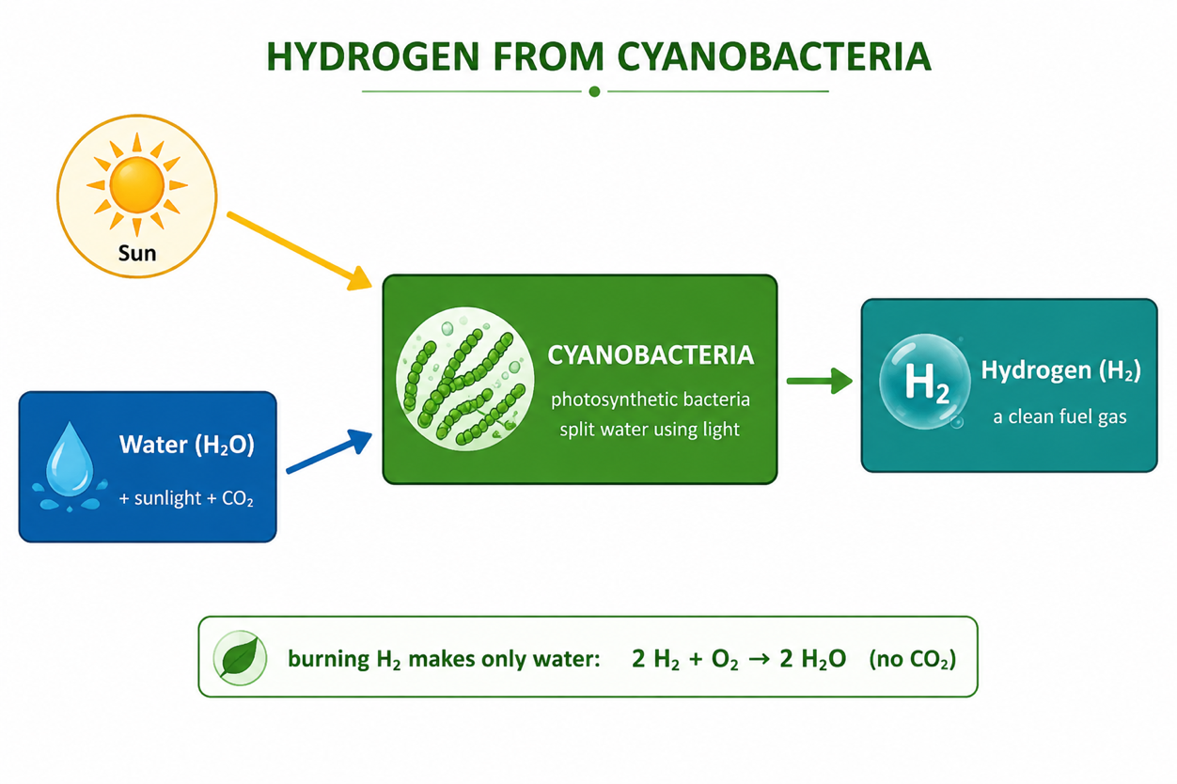
Figure 1: Cyanobacteria use sunlight and water to make hydrogen -a clean fuel that burns to water.
Terminologies and Concepts
Useful terms for this topic:
- Biohydrogen: hydrogen gas produced by living organisms.
- Cyanobacteria: photosynthetic bacteria (blue-green algae) that can make hydrogen.
- Biophotolysis: using light energy to split water and release hydrogen.
- Hydrogenase: an enzyme that produces (or takes up) hydrogen gas.
- Nitrogenase: an enzyme that fixes nitrogen and can release hydrogen as a by-product.
- Heterocyst: a special thick-walled cyanobacterial cell that keeps oxygen out.
- Bioreactor: a controlled vessel in which microbes are grown to make a product.
How Cyanobacteria Make Hydrogen
Cyanobacteria can make hydrogen by biophotolysis -using light energy to split water. There are two main routes, and the difference between them is about how they deal with oxygen:
Direct Biophotolysis
In direct biophotolysis, light energy splits water directly, and the enzyme hydrogenase combines the released hydrogen ions and electrons into hydrogen gas (H₂). The problem is that oxygen (O₂) is produced at the same time, and oxygen inhibits the hydrogenase enzyme -so hydrogen production quickly stops.
Indirect Biophotolysis
In indirect biophotolysis, the two steps are separated in time. First the cyanobacteria photosynthesise normally, storing energy as carbohydrate (and releasing oxygen). Later, in the absence of oxygen, they ferment the stored carbohydrate and release hydrogen. Separating the oxygen-making and hydrogen-making steps protects the enzymes.
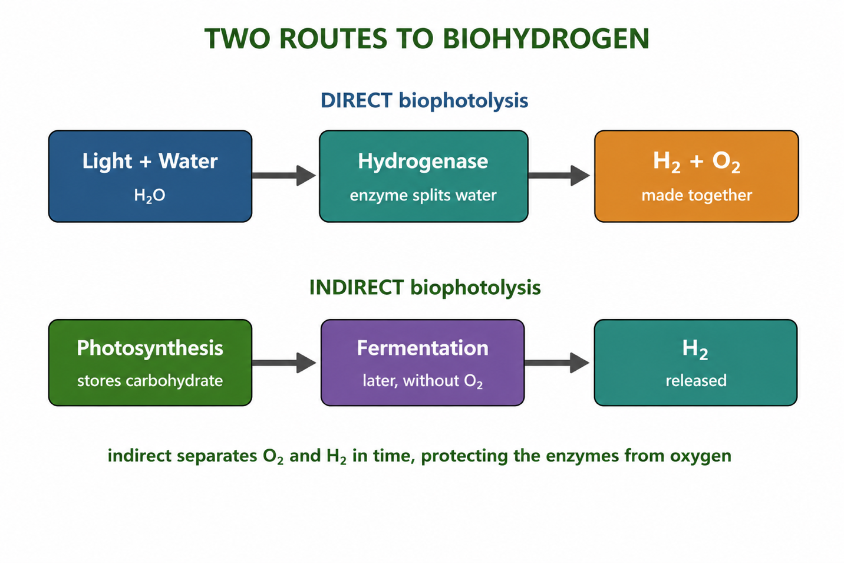
Figure 2: Two routes to biohydrogen -direct biophotolysis, and indirect biophotolysis that separates O₂ and H₂ in time.
The Enzymes and the Oxygen Problem
Two enzymes can make hydrogen in cyanobacteria: hydrogenase and nitrogenase. Nitrogenase is normally used to 'fix' nitrogen gas from the air, and it releases hydrogen as a by-product. The key difficulty for both enzymes is that they are damaged by oxygen -yet photosynthesis itself produces oxygen. This 'oxygen problem' is the main challenge in making cyanobacterial hydrogen.
Some cyanobacteria solve this naturally using special cells called heterocysts. A heterocyst has a thick wall that keeps oxygen out, giving nitrogenase an oxygen-free space to work in. This is one reason heterocyst-forming cyanobacteria are studied so closely for hydrogen production.
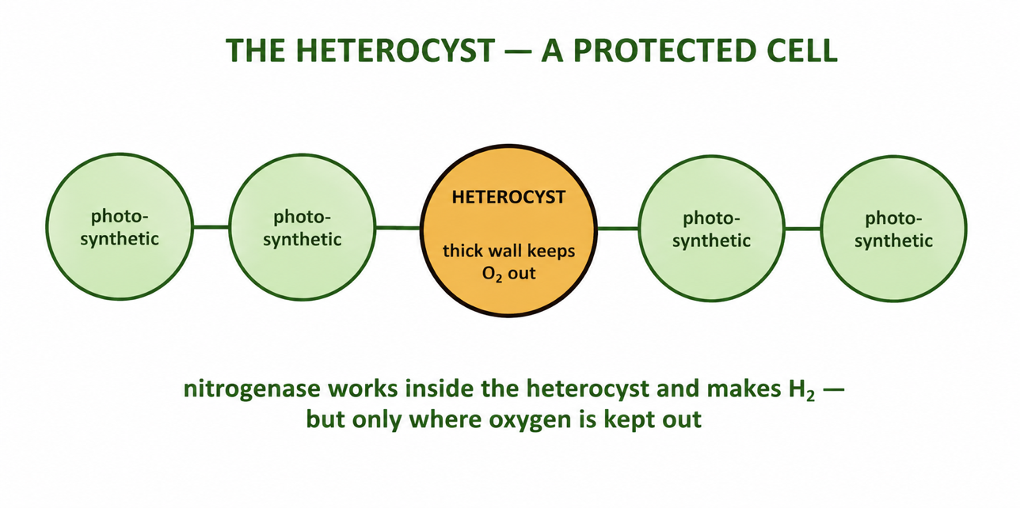
Figure 3: In heterocyst-forming cyanobacteria, nitrogenase works inside the oxygen-free heterocyst.
Growing Cyanobacteria for Hydrogen
To collect hydrogen in a useful way, cyanobacteria are grown in a photobioreactor -a clear, sealed vessel that lets in light while excluding air and capturing the gas produced. Researchers control the light, temperature, nutrients and oxygen level to keep the enzymes active and increase the hydrogen yield. This technology is still mostly at the research stage, because the yields are currently low, but it holds great promise for clean fuel in the future.
Advantages and Disadvantages
Advantages | Disadvantages
Uses sunlight and water -abundant and renewable | Yields are currently low
Hydrogen is a clean, carbon-free fuel | Enzymes are damaged by oxygen (the oxygen problem)
Cyanobacteria grow on simple nutrients | Needs specialised photobioreactors
No competition with food crops for land | Still mostly at the research and development stage
Worked Example -Splitting Water for Hydrogen
In biophotolysis, light energy is used to split water into hydrogen and oxygen:
2 H₂O →(light)→ 2 H₂ + O₂
The cyanobacteria capture the light energy and use their enzymes to release the hydrogen (H₂). Later, when this hydrogen is burned as fuel, the reaction reverses -2 H₂ + O₂ → 2 H₂O -releasing energy and reforming water. This shows why hydrogen is described as a clean fuel: the only product is water.
Why This Matters
- Clean energy -hydrogen burns to water only, with no carbon dioxide.
- Renewable -the fuel is made from sunlight and water using living cells.
- Biotechnology -it shows how microbes can be harnessed to solve energy problems.
- Future fuel -hydrogen is a leading candidate for clean transport and power.
PNG Context Example
Papua New Guinea has two of the key ingredients in abundance: strong year-round sunlight and plentiful water. Cyanobacteria are also common in PNG's warm freshwater ponds, wetlands and coastal waters. While cyanobacterial hydrogen is still experimental worldwide, PNG's climate makes it a promising long-term option for clean, locally produced fuel. In the near term, studying cyanobacteria connects PNG students to cutting-edge biotechnology and renewable-energy research and builds understanding of photosynthesis and enzymes.
References & Related Documents
Source Documents
- STEM Biology Syllabus -Grade 12. Thema: Energy; Module 12.1 Bioenergy (Hydrogen Production via Photosynthesis). Department of Education, PNG.
- Biology Standards-Based Syllabus, Grades 11 & 12 (PNG SBC 2020) -Strand 2: Life; examine the chemical reactions of photosynthesis and the cycling of energy and matter through living systems.
Further Reading & References
- OpenStax Biology -Photosynthesis; The Light-Dependent Reactions. https://openstax.org/books/biology
- Khan Academy -Photosynthesis and the light reactions. https://www.khanacademy.org/science/biology

